PRIVACY NOTICE
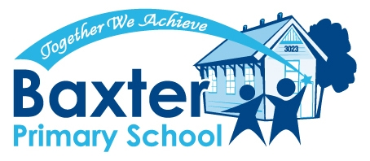

Information about the Enrolment Form.
Please Read This Notice Before Completing the Enrolment Form.

This confidential enrolment form asks for personal information about your child as well as family members and others that provide care for your child. The main purpose for collecting this information is so that Baxter Primary School can register your child and allocate staff and resources to provide for their educational and support needs. All staff at Baxter Primary School and the Department of Education & Training are required by law to protect the information provided by this enrolment form.

Health information is asked for so that staff at Baxter Primary School can properly care for your child. This includes information about any medical condition or disability your child may have, medication your child may rely on while at school, any known allergies and contact details of your child’s doctor. Baxter Primary School depends on you to provide all relevant health information because withholding some health information may put your child’s health at risk.

Baxter Primary School requires information about all parents, guardians or carers so that we can take account of family arrangements. Family Court Orders setting out any access restrictions and parenting plans should be made available to Baxter Primary School. Please tell us as soon as possible about any changes to these arrangements. Please do not hesitate to contact the Principal if you would like to discuss, in strict confidence, any matters relating to family arrangements.

Emergency Contacts
These are people that Baxter Primary School may need to contact in an emergency. Please ensure that the people named are aware that they have been nominated as emergency contacts and agree to their details being provided to Baxter Primary School.

Student Background Information
This includes information about a person’s country of birth, aboriginality, language spoken at home and parent occupation. This information is collected so that Baxter Primary School receives appropriate resource allocations for their students. It is also used by the Department to plan for future educational needs in Victoria. Some information is sent to Commonwealth government agencies for monitoring, planning and resource allocation. All of this information is kept strictly confidential and the Department will not otherwise disclose the information to others without your consent or as required by law.

Religious Affiliation
If you want your child to receive religious instruction while at Baxter Primary School please complete this section. The Department of Education & Training needs to know what type of religious instruction is sought so the Department can, where possible, provide appropriate religious instruction at Baxter Primary School

Immunisation status
This assists Baxter Primary School in managing health risks for children. This information may also be passed to the Department of Human Services to assess immunisation rates in Victoria. Information sent to the Department of Human Services is aggregate data so no individual is identified.

Visa status
This information is required to enable Baxter Primary School to process your child’s enrolment.

UPDATING YOUR CHILD’S RECORDS
Please let Baxter Primary School know if any information needs to be changed by sending updated information to the school office. During your child’s time with Baxter Primary School we will also send you copies of enrolment information held by us. Please use this opportunity to let us know of any changes.

ACCESS TO YOUR CHILD’S RECORD HELD BY SCHOOL
In most circumstances you can access your child’s records. Please contact the Principal to arrange this.
Sometimes access to certain information, such as information provided by someone else, may require a Freedom of Information request. We will advise you if this is required and tell you how you can do this.

If you have any concerns about the confidentiality of this information please contact the Principal. Baxter Primary School can also provide you with more detailed information about privacy policies that govern the collection and use of information requested on this form. This form is available on request.

